الكيمياء الفيزياء
المرحلة الثانية
المحاضرة الاولى

Lecture 1
page 1
Thermodynamics
0 ^{th} Law ⇒ Defines Temperature (T)
1 st Law ⇒ Defines Energy (U)
2 nd Law ⇒ Defines Entropy (S)
Thermodynamics: Deal with properties of system at equilibrium, time is not included. It is concerned with initial and final state.
concerned with initial and final state.
Definitions:

System: a thermodynamic system is a part of the universe that under consideration. It is separated from the rest of the universe by a boundary.
Surrounding: It is a part of the universe outside the boundary of the system.
Isolated System: The system in which the boundary prevents interaction between the system a its surrounding. Or neither mass nor energy can transfer between the System and the Surroundings
Closed system: The system in which the materials cannot transfer from the surrounding to system or vice versa, but the system may exchange work or heat with its surrounding.
Open system: the system in which the materials can transfer from the surrounding to system or vice versa.
Homogeneous system: system with uniform properties, such a system consists of a single phase.
Heterogeneous system: The system with more than one phase.
Adiabatic System: the system in which there is no exchange of heat through boundary between the system and its surrounding.

Lecture #1
page 2
Describing systems requires:

• A few macroscopic properties: p, T, V, n, m, …

• Knowledge if System is Homogeneous or Heterogeneous

• Knowledge if System is in Equilibrium State

• Knowledge of the number of components
Two classes of Properties:
• Extensive: Depend on the size of the system )n, m, V,….)
• Intensive: Independent of the size of the system (T, p, Ṽ =V/n……..)
The amount of substance n is the number of (atoms, molecules, ions, electrons, or specified groups of such particles) expressed in term moles

The State of a System at Equilibrium:
• Defined by the collection of all macroscopic properties that are described by State variables (p, n, T, V ,….) [INDEPENDENT of the HISTORY of the SYSTEM
Equation of State:
P V= n R T
For a one-component System, all that is required is "n" and 2 variables.
All other properties then follow.
V= f (n, p, T) OR P = f (n, V, T)
3 H 2 (g, 1 bar, 100 °C)
3 moles (n=3) gas p=1 bar T=100 °C
2 Cl 2 (g, 5 L, 50 °C) 5 Ar (s, 5 bar, 50 K)

Lecture #1
page 3
,

Lecture #1
page 3
Change of State:

• Notation:
(Transformations)
3 H 2 (g, 5 bar, 100 °C) = 3 H 2 (g, 1 bar, 50 °C)
Initial state
Final state
• Path: Sequence of intermediate states
5
p (bar)
1
50
100
T (K)
• Process: Describes the Path

- Reversible (always in Equilibrium)
- Irreversible (defines direction of time)
- Adiabatic
- Isobaric
- Isothermal
(No heat transfer between system and surroundings)
(constant pressure)
(constant temperature)
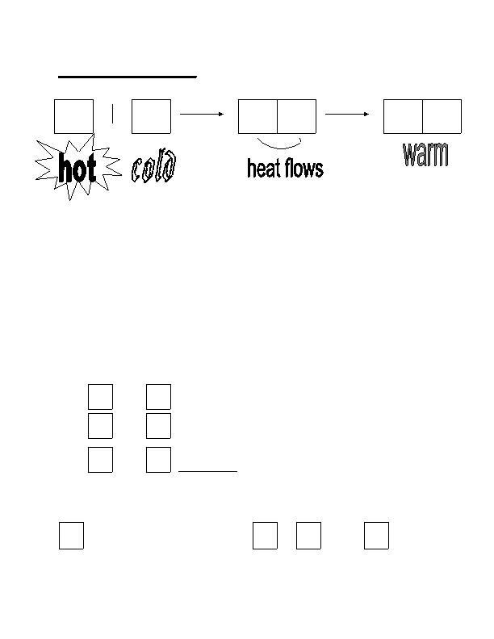

Lecture #1
page 4
Thermal Equilibrium (heat stops flowing)

A B A B
A B
When a hot object is placed in thermal contact with a cold object,
heat flows from the warmer to the cooler object. This continues
until they are in thermal equilibrium (the heat flow stops). At this
point, both bodies are said to have the same "temperature".
This intuitively straightforward idea is formalized in the 0th Law

thermodynamics and is made practical through the development of
thermometers and temperature scales.

≡≡≡≡≡ ZERO'th LAW of Thermodynamics ≡≡≡≡≡
If
then
A

B

A
and

and

and
B

C

C
are in thermal equilibrium and

are in thermal equilibrium,

are in thermal equilibrium.
Consequence of the Zero^{'th} law:

B acts like a thermometer, and A ,

at the same "temperature".
B
, and
C are all
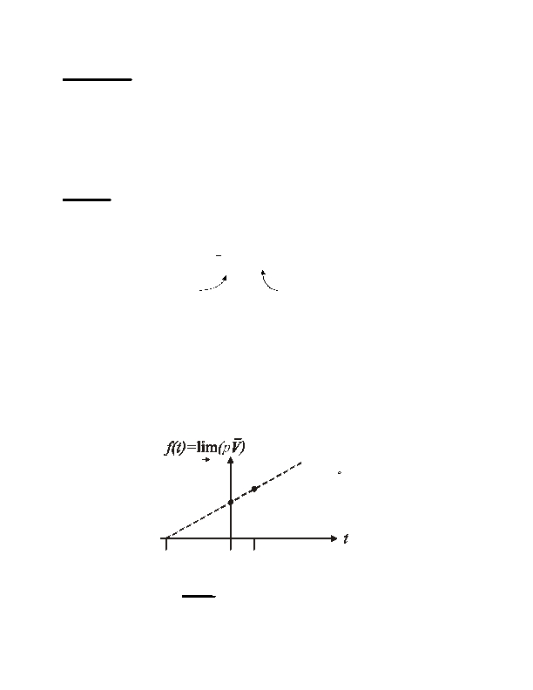

Lecture #1
page 5
Operational definition of temperature (t)
Need:
(1)
(2)
(3)
(4)
Substance
Property that depends on t
Reference points
Interpolation scheme between ref. pts.
Example: Ideal Gas Thermometer with the Celsius scale.

Based on Boyle's Law
lim (pV
p →0

for fixed t
) = constant = f (t )
t

depends on t
• The substance is a gas
• f(t ) is the property
• The boiling point (t = 100°C ) and freezing point (t
b
of water are the reference points
• the interpolation is linear
f
= 0°C
)
p
0
-273.15

Note:
f(t)=f(0 C)(1+At)
Experimental result:
A = 0.0036609 = 1/273.15

0 100 C

(t = −273.15°C ) is special
t = −273.15°C is called the absolute zero,
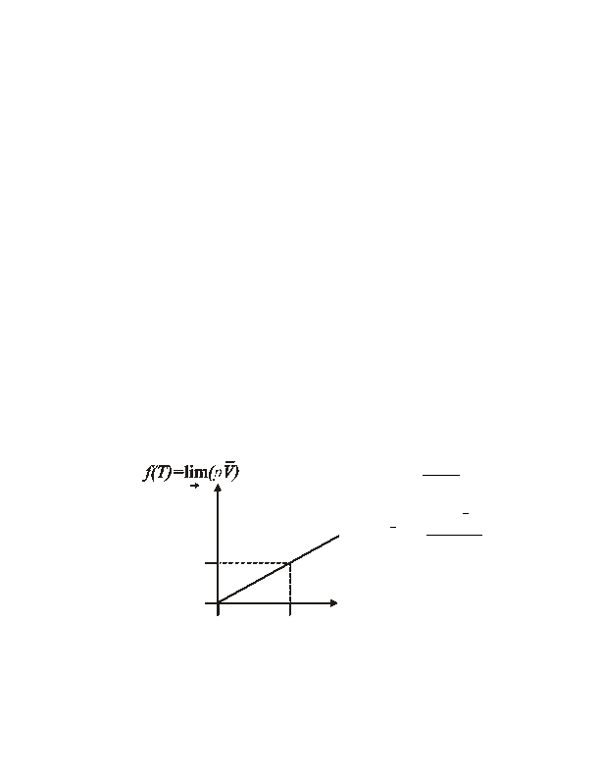

Lecture #1
page 6
=======

This suggests defining a new temperature scale (Kelvin)

T (K ) =t (°C ) + 273.15

T = 0 K corresponds to absolute zero (t = −273.15°C )

=======
Better reference points used for the Kelvin scale today are

T = 0K (absolute zero) and T tp = 273.16K (triple point of H 2O)
f (T ) =
f Ttp
(
)
(
)
T
(
)
tp
= ⎢
⎢
⎣⎢
273.16
or

⎡lim pV
p →0
T
p
0
lim pV
p →0
f(T tp)

0
273.16
⎤
⎥T
⎥
⎥⎦
0
T(K)
273.16= Ttp

Lecture #1
page 7
Ideal Gases

Boyle's Law and the Kelvin scale
An ideal gas obeys the expression pṼ = RT at all pressures
(⇒ the gas molecules do not interact)

V =f (n, pT )
,
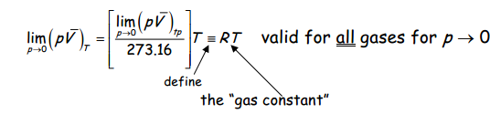
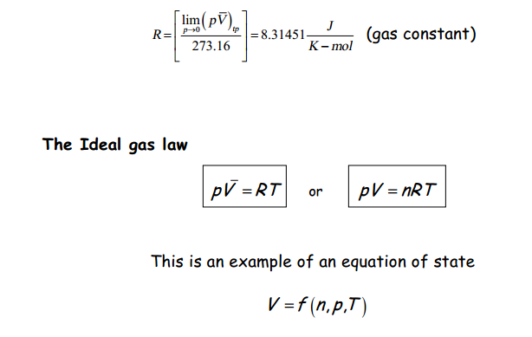


Lecture #1
page 8
Equations of state

IDEAL GAS LAW: pV = nRT
→
pV = RT
Mixture of ideal gases comprising n i moles of each
n iRT
V
p = pTotal
pi

= ∑ p i
i
=

;
Xi
=
ni
n

Partial pressure of i^{th} gas

mole fraction of i^{th} gas
pi
= p = X i p
n
ni
Dalton's Law
Real Gases
(a)
--
do not necessarily obey ideal gas law
Compressibility factor
pV =ZRT
Z =
V
real
V ideal
High T ⇒

Low T ⇒
Repulsions dominate

Attractions dominate
Z > 1

Z < 1
Vreal

Vreal
>Videal

<Videal
(b) Virial Expansion
pV
RT
= Z (T ) = 1 +
Generally neglect

B (T ) C (T )
V
+
V
2
+ "
As p → 0,V → ∞, ⇒ ideal gas
B =
0 ⇒ ideal gas
(Neglect C and higher order terms)

Lecture #1
page 9
(c) van der Waals Equation of state

Only two parameters, derived from molecular concepts

• First assume "hard sphere" molecules
P V = RT becomes
P(V − b) = RT

